- Duration in Millisekunden
Move:
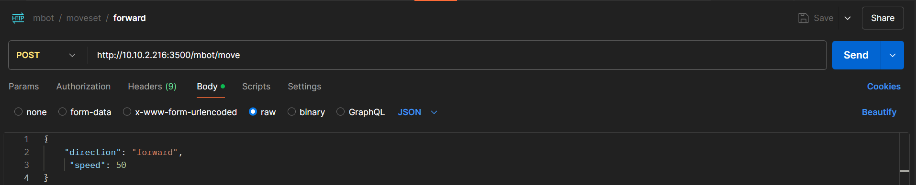
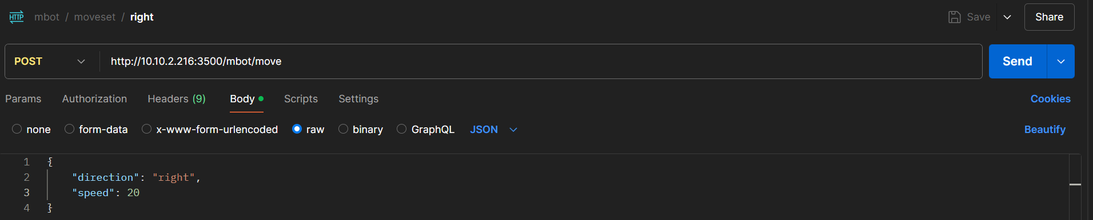
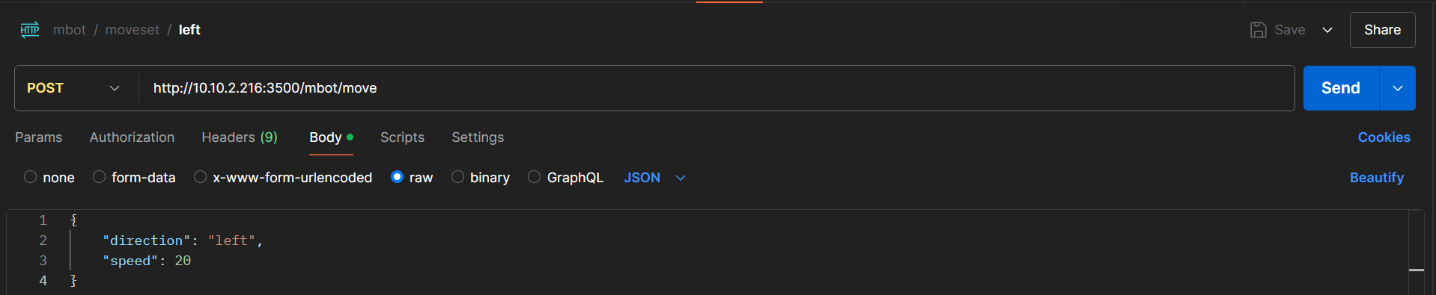
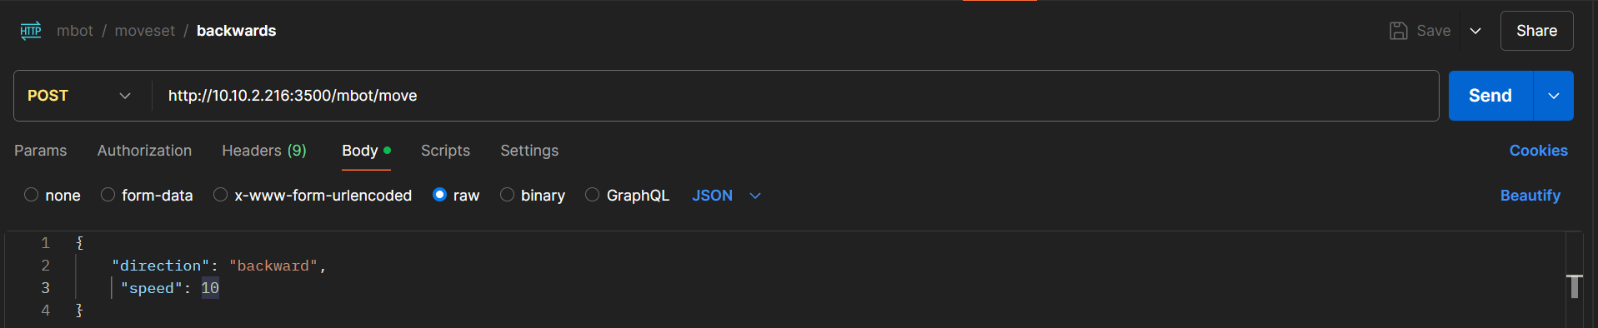

Track:
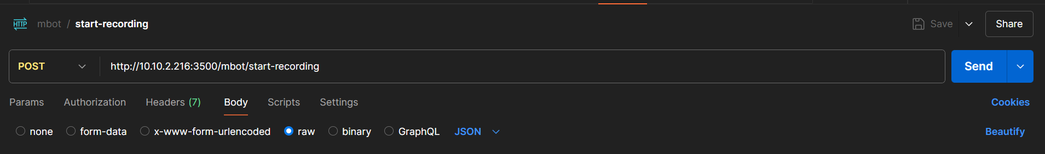

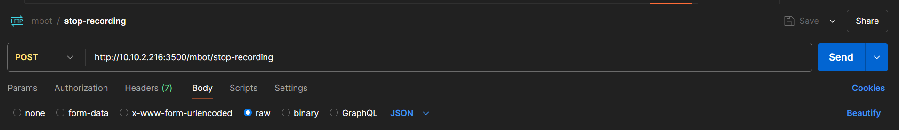

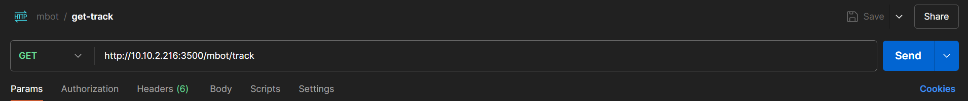

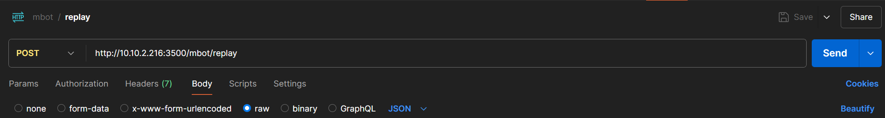

Befehlsreihe:

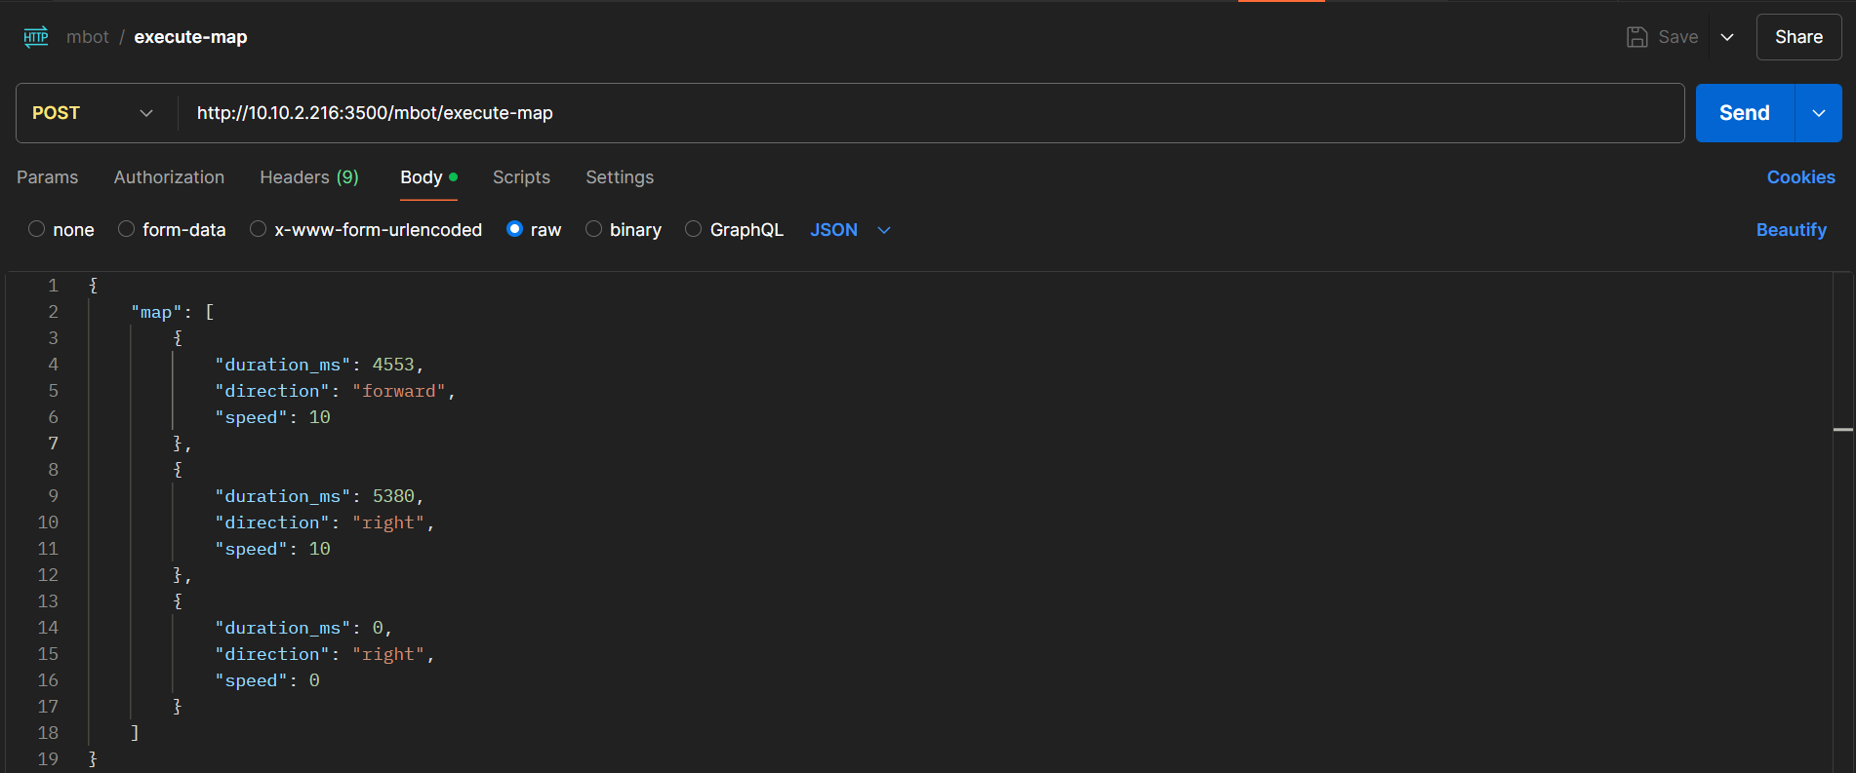

LED:

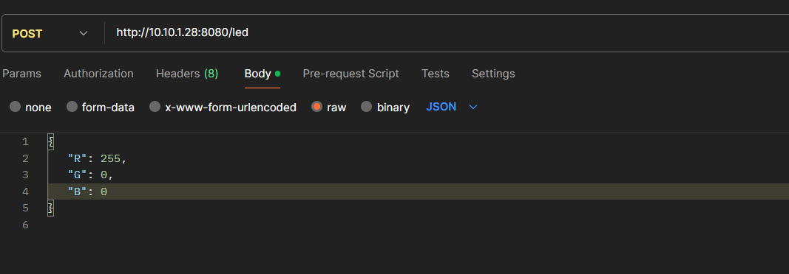
Sensors:


